- The link to RevRunner is:
  - https://relayhealth.relayclearance.com/MCHOdessa/
  - Please create a short cut to your desk top for easy access.
- You will be provided a user name and an initial password for your login
  - You will create a new password after your first login
  - Once you login, on the top right hand side of that first screen you will see four buttons. The first button that looks like a person standing is a link to your profile page.
  - Click on that button to change your password.
  - Once you change your password you might be directed to log back in.
  - RevRunner is linked to AS400 and it keeps track of all accounts you are working on. Once you register an account it starts looking for that patient’s insurance and obtaining benefits for you.
  - It is a good idea to keep RevRunner up while you are at work. It will automatically notify you when benefits are obtained with a pop up screen.
- After you log back in, you are at the main page to RevRunner.
- At your top left side you will see four tabs labeled as follows:
  - Verifier
  - Advocate
  - Patient View
  - Connect
- The only ones you will use are:
  - Verifier
  - Patient View
  - Connect
- Verifier
  - Under Verifier are three subtitles. The only one you will use is the one entitled “Realtime”.
  - Realtime would be used if you are trying to get benefits for someone who is already registered. An example would be if you registered a patient and RevRunner was down at the time. You can go to Realtime another day and under the “Eligibility” tab input all the information you have regarding that patient’s insurance and then click submit.
  - If it is able to locate the insurance, it will give you all the specifics as far as deductible, out of pocket, co-insurance, etc.
  - Sometimes RevRunner is not connected to a payer and you have to call the insurance company to obtain benefits.
- Patient View
  - Patient view is used to obtain benefits on a patient that either you didn’t register and are now trying to work or time has passed and you need to look at the benefits again.
  - You will only need to put the account number in the field under “PAN:” and click “Search”.
    - If benefits are available it will bring you to the “Records” screen where you will then be able to click on that patient and see their benefits.
- Connect
  - This is the main screen you will utilize when running RevRunner.
  - (Repeat from II E above) RevRunner is linked to AS400 and it keeps track of all accounts you are working on. Once you register an account it starts looking for that patient’s insurance and obtaining benefits for you.
  - (Repeat from II F above) It is a good idea to keep RevRunner up while you are at work. It will automatically notify you when benefits are obtained with a pop up screen.
  - You will click on the magnifying glass to be able to go into a patient’s actual insurance benefit.
  - Once in a patient’s individual insurance record, click on “Benefit Summary” to obtain the following so you can estimate the cost to patient:
    - Co-Insurance
    - Deductible
      - Make sure to write down the amount remaining.
    - Out of pocket
      - Make sure to write down the amount remaining.

**It is important to remember that RevRunner shows you the amount remaining, not the amount used on the deductible and out of pocket.

Login Page Screenshot

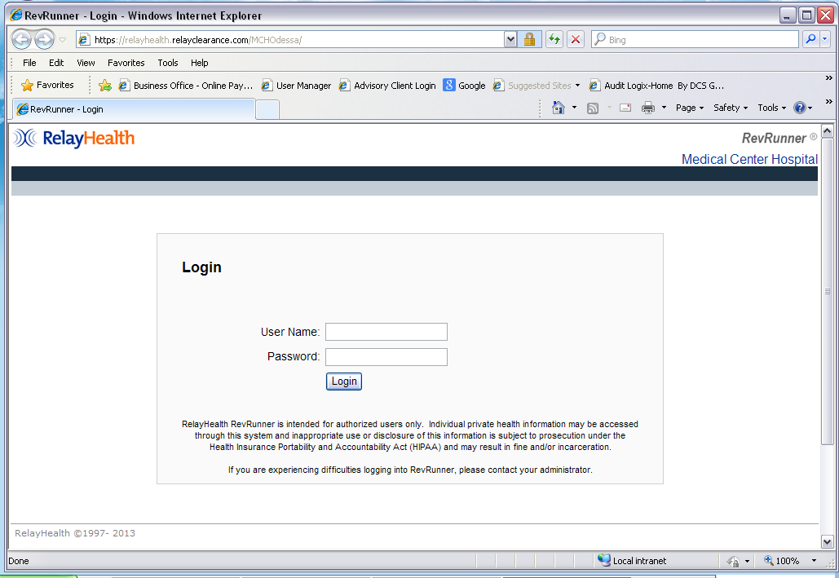

Realtime Page Screenshot

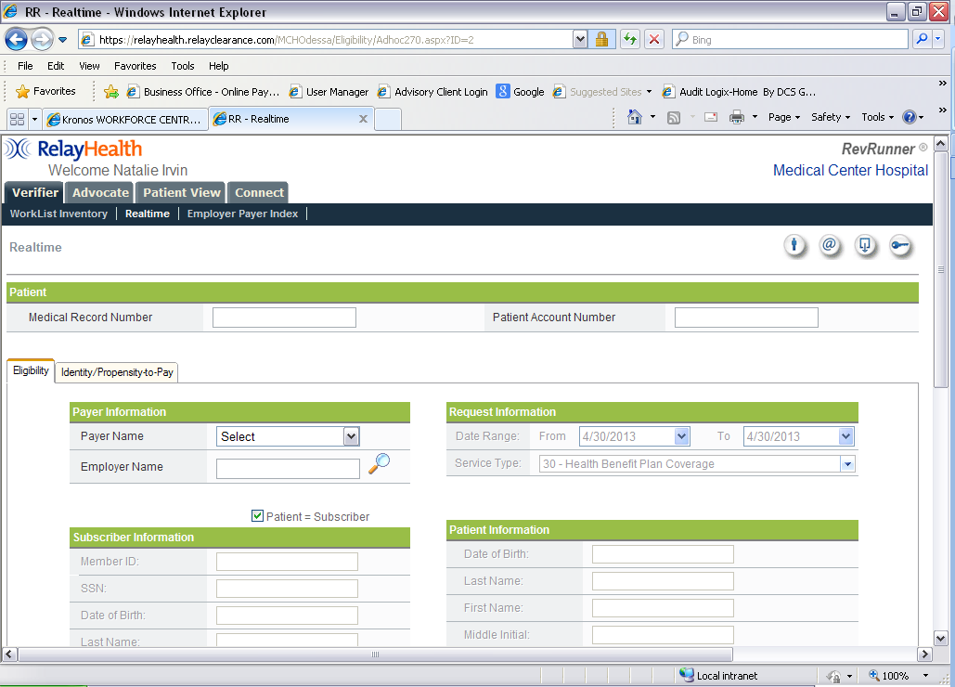

Patient View Screenshot

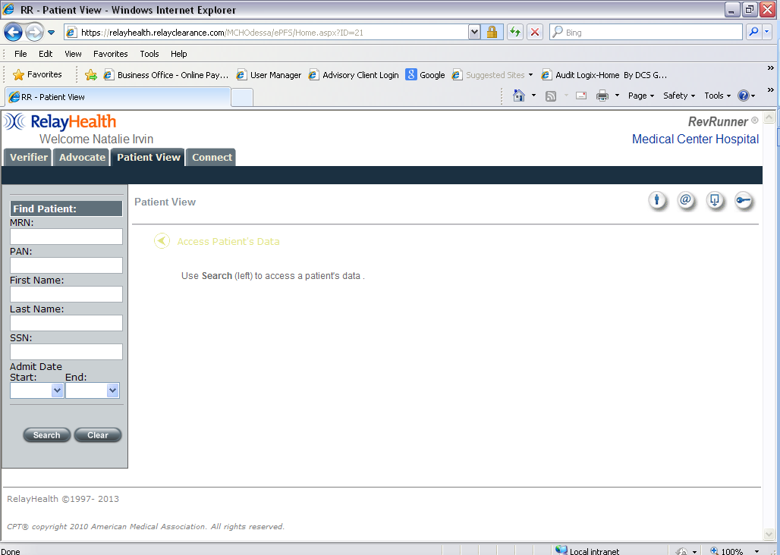

Connect Page Screenshot
