ON-LINE PAYMENTS

- The link for the Online Payments is below with a screenshot of what it looks like on the first screen.
- You can also get to this screen by going to www.mchodessa.com, click on Medical Center Hospital, click on billing, then click on “Online Payments”. This link is much faster though!
- You will follow the instructions for each field and each screen.
- After you submit the payment, a verification number will come up on the screen with the payment information with it. You must print this screen and either email it to the customer for mail it to them if they are not in front of you! This is the only receipt we can give them for online payments.

LINK TO ONLINE PAYMENTS:
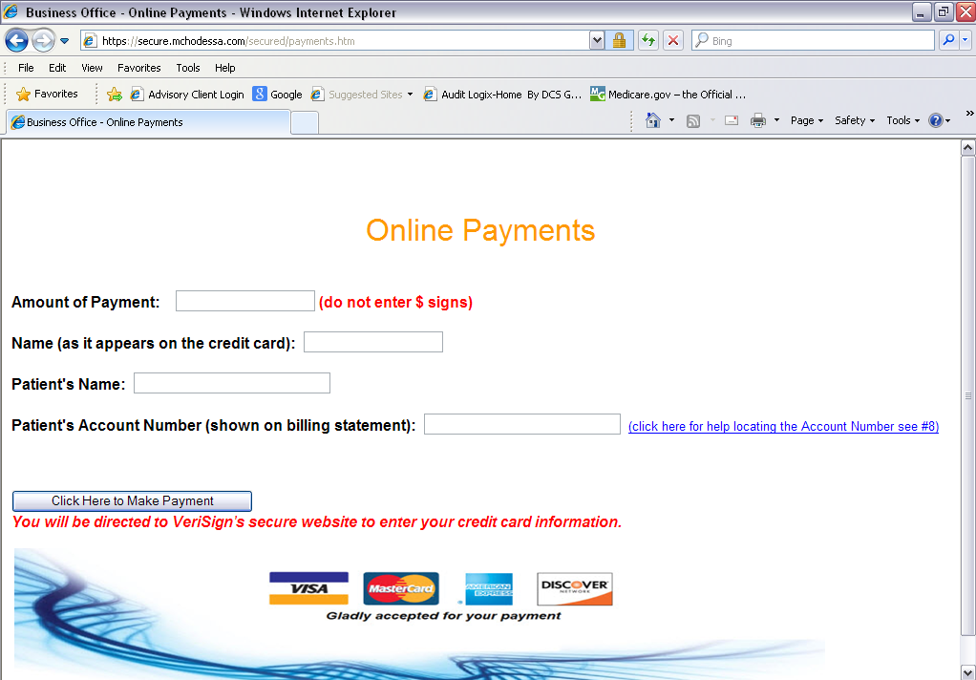
https://secure.mchodessa.com/secured/payments.htm

