Citrix Instructions for Remote Users
Welcome to the Medical Center Health System, as a remote user there are a few steps that need to be followed to get you into our system.
- Go to www.mchodessa.com
- Click the Other Remote User link at the bottom of the page
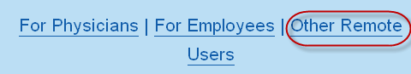
- Click on Citrix Login
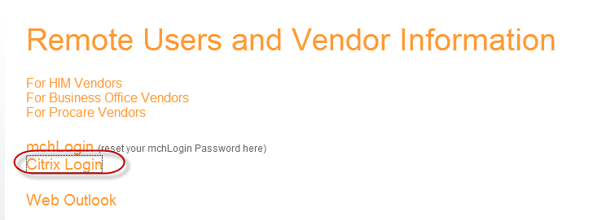
(Alternate method would be to go to http://access.echd.org )

- Enter username and password | Click OK
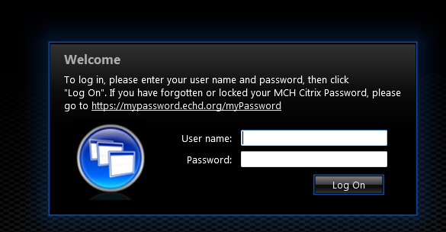
- Click the icon for the program you are opening.
