Medical Center Hospital HIM Coders
Welcome to the Medical Center Health System, as a coder for the Health Information Management department (HIM) there are a few steps that need to be followed to get you into our system.
- Go to www.mchodessa.com
- Click the Other Remote User link at the bottom of the page
- 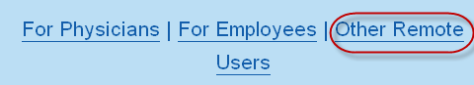
- Click mchLogin (reset your mchLogin Password here)
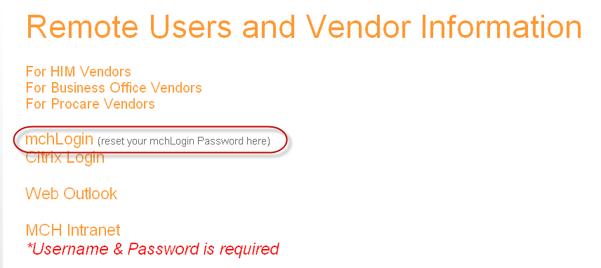
  - Click Change my Password.
    - Call 432-640-1385 and ask for the temporary password, the temporary password is only good for logging in and changing your password, it will not work in any of the application. This temporary password will also be for the AS400, when you enter the AS400 for the first time you will be prompted for a password, please use the same password as your mchLogin, these two being in sync will allow you into the AS400 without being prompted each time. At this time also ask for the temporary password for HPF, you will need it further along in the setup process.
    - Then login with your username, which was send to you by email and the temporary password.
    - mchLogin will prompt you to change your password. Passwords need to contain 3 of the four character sets (uppercase, lowercase, numbers, special characters); the password should be between 7-10 characters long. When creating a password we ask that you use a pass phrase for a stronger password.
      - A passphrase is created by thinking of a phrase or sentence that you will remember and using the first characters of the word. An example is: Today is a fine day to work at home; which could be the phrase for Tiafd2w@h this is easy for you to remember but a hard password to crack.
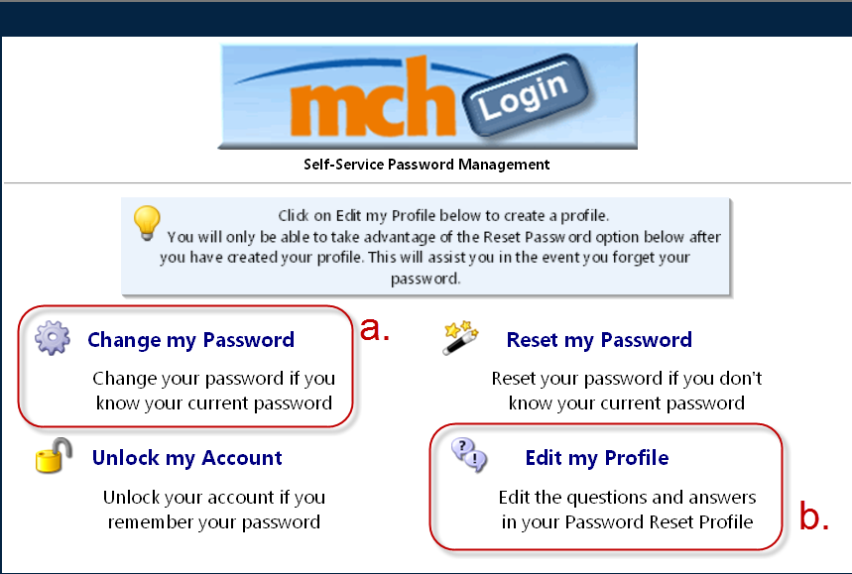
  - Go back to mchLogin, click Edit my Profile, choose two questions and answer the questions. This will give you the ability to unlock or change your password when necessary.
  - The mchLogin password that you setup here will be your password for Citrix, and logging in.

