Business Office Log into Citrix XenDesktop
Welcome to the Medical Center Health System, as a remote user for Proclick there are a few steps that need to be followed to get you into our system.
- Go to www.mchodessa.com
- Click the Other Remote User link at the bottom of the page
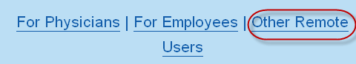
- Click on Citrix XenDesktop or go to http://mypc.echd.org
- Enter username and password | Click OK

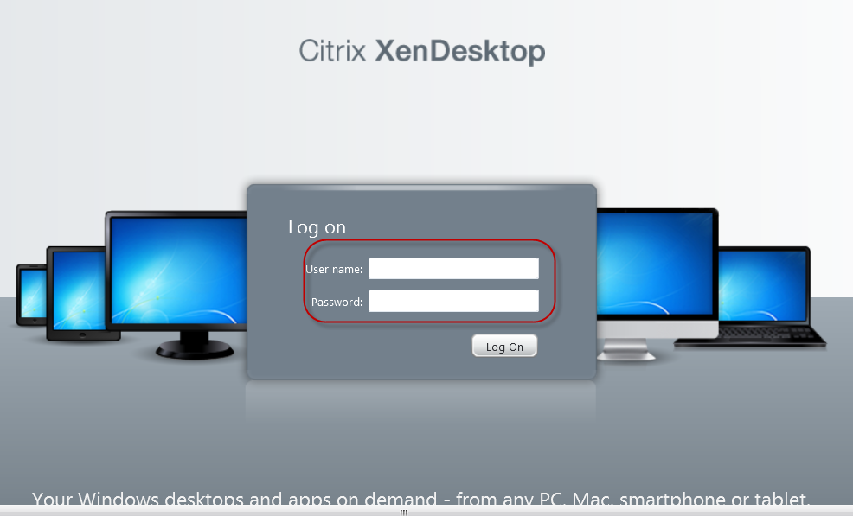
- Click on monitor icon

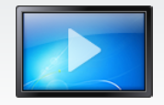
- You are now at the Windows Desktop

