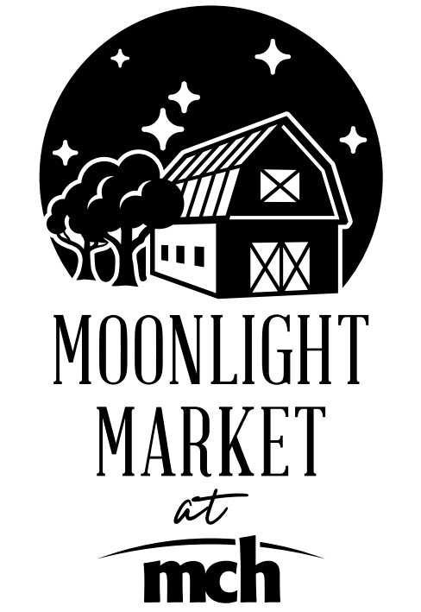

Acknowledgement of 2022 Policies and Procedures

Introduction
The Moonlight Market at MCH (formerly known as the Odessa Texas Farmers Market) goal is to promote health and wellness to our region by providing a farmers market where the community can purchase a variety of locally grown, farm fresh produce and related products. The Moonlight Market (herein referred to as “Market”) is part of Medical Center Health System (MCHS) and Ector County Hospital District (ECHD). The Market operates in accordance with all city, county, state and federal laws pertaining to its operation. The Market is a health and wellness program sponsored by Medical Center Health System.
Market Season and Hours
The market season will begin with a kickoff Market on the 3rd Friday in May and continue on the 4th Friday of every month starting in June and ending in September.
Market hours are from 6:00 pm – 8:00 pm.

Market Location
Medical Center Hospital, corner of 3rd and Alleghaney, Odessa, Texas
Applications
Applications must be submitted annually, one month prior to the first scheduled Market, to be eligible to sell at the first Market of the season. Vendors may be accepted throughout the season at the discretion of the Market.
Market Fee
Vendors participating in the Market will have the fee waived for their first two years. The third year and subsequent years, the fee is $75 for the season, required with the application. Once accepted as a vendor, the fee is non-refundable. There is no discount if unable to attend one or more markets. If the vendor’s participation is terminated by the Market (for any reason), no refund will be made. Please note that the vendor fee does not carry with it any guarantees.

Absence
Vendors must notify the Market Manager by the Monday before the Market if they are to be absent. Failure to provide notice, late arrival or a no-show absence may result in forfeiture of right of participation for the current season. Each occurrence will be determined on a case-by-case basis.
Market Cancellations
The Market will be cancelled if inclement weather arises. The Market Manager will communicate with you via email or text for Market cancellations and to provide updates. Vendors can call/text/email the Market Manager for additional information.
Admission of Product
Only items approved by MCHS can be sold. If additional items would like to be added during the season, Vendor must contact the Market Manager for product approval prior to the Market at which the product will be sold.
Vendor Spaces
Vendor spaces will be assigned at the sole discretion of MCHS. Booth location may change during the course of the season. Vendor must ensure that no trash or any other items are left behind and the space is left in a clean and neat condition. Vendors are encouraged to bring a sign that includes a business name and logo. Vendor spaces/booths must not encroach on neighboring vendor booth areas or market walkways.
Vendor Equipment
Vendor is responsible for all equipment needs. This includes tables, chairs, tents or other shade devices, electrical equipment (electricity can be provided for vendors that require it only if noted in the application), sacks, boxes, etc. Due to windy West Texas weather, tents should be safely secured and not a hazard to fellow vendors or to the public. Stakes may not be used.
Set-up and Tear-down
Vendors may arrive as early as 4:00 pm and must be ready to sell to the public when gates open at 6:00 pm. The Market closes at 8:00 pm and all sales must be completed by that time. Vendors should not depart the Market premises until they have completely cleared their area including (but not limited to) packing up all remaining products, collapsing canopies or tents and cleaning up any trash or debris.
Parking
Vendor parking will be designated. Vendors may not park in any fire lane or restricted area. For safety reasons, vendor vehicles will not be allowed to move during the Market hours of operation. To do so may result in loss of permission to participate in the Market.
Tobacco Use
For the health of our patients, visitors and staff, Medical Center Hospital is a tobacco free campus. Further, all events sponsored by MCHS are tobacco free. Smoking or any form of tobacco use of any kind is prohibited. Vendors may be permanently removed from the Market for violating the tobacco policy.
Authorized Agents
Sales by other family members and/or employees, also known as “agents” are permitted. You are responsible for all agents in your business. By signing the application you acknowledge that you accept responsibility and liability for all agents and their actions.
Professional Code of Conduct
In the spirit of professionalism, vendor shall conduct themselves in a manner that represents the Market with dignity and respect. Vendor will demonstrate civility and professionalism; refrain from the use of inappropriate or intimidating language; support fellow vendors and staff in a positive manner; and always treat other vendors, staff and market customers with courtesy and respect. Vendor agrees to exercise the utmost care in the use of facilities and properties belonging to ECHD/MCHS. Should a vendor at any time occupy the premises in a manner contrary to the rules of the Market, or in a manner that is hazardous or offensive to the public, said vendor will be asked to cease the offending conduct by the Market Manager or other MCHS officials. Failure to immediately conform conduct as requested shall be cause to revoke this agreement and the vendor permit. The Market is relieved and discharged from any and all loss or damage occasioned by such removal.
Responsibility and Adherence to the Law
It is the responsibility of the vendor and agents to contact the Ector County Health Department, the Texas Comptroller’s Office and any other regulating entity for questions regarding licensures and laws of Texas, Ector County and the City of Odessa. Vendor must furnish their own permits and licenses if required by any regulating entity. Failure to do so may result in immediate forfeiture of vendor’s participation for the remainder of the season.
Limitation of Liability
Vendor agrees ECHD/MCHS (sponsors of the Market) and its members, officers, directors, affiliates, employees, attorneys, resellers, partners and agents will not in any event be liable for any money damages whatsoever including direct, indirect, special exemplary, incidental, punitive or consequential damages, whether such liability is based on contract, tort (including negligence), or any other legal or equitable grounds.
Indemnification
Vendor agrees to indemnify and hold harmless ECHD/MCHS, its agents and employees or any other person against and/or from all costs, losses, damages, liabilities, expenses, penalties, and fines, including attorney’s fees, by reason of the liability imposed by law upon ECHD/MCHS, for damage because of bodily injury, including death at any time resulting there from, sustained by any person or persons, or on account of damage to property arising out of or in consequence of this agreement, whether such injuries to persons or damages to property are due or claim to be due to any passive negligence of ECHD/MCHS, its agents or employees or any other person. It is further understood and agreed that Vendor shall, at the option of ECHD/MCHS defend ECHD/MCHS with appropriate counsel and shall further bear all costs and expenses, including the expense of counsel, in the defense of any suit arising hereunder.

By signing this document, Vendor declares it has read and agrees to all rules and regulations.
Business Name
Owner Name
Signature Date

