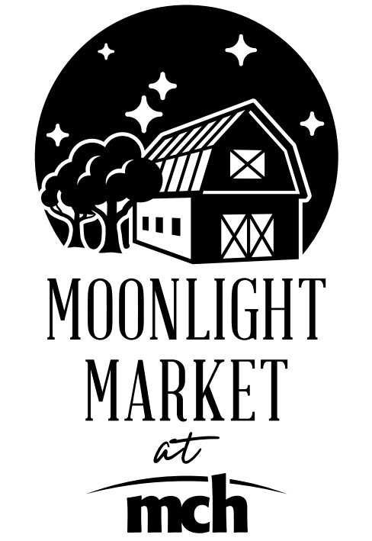

2022 Vendor Application
Business Name ____________________________________________________________
Owner Name ______________________________________________________________
Mailing Address ____________________________________________________________
Email ____________________________________________Phone __________________
Electricity needed? ________
Product (please check all that apply)
____ Produce ____ Beverages
____ Bread/Baked Goods ____ Herbs
____ Eggs/Dairy ____ Soap/Bath Salts
____ Meat ____ Flowers/Plants
____ Nuts/Granola ____ Jams/Jelly/Honey/Butters
____Animal Food ____ Other (please describe below)
________________________________________________________________________
All edible items sold at the Moonlight Market at MCH must be grown and produced in Texas. This includes fruits, vegetables, prepared foods, herbs, nursery products or similar.
All Artisans/Crafters must create their own items.

Farm Address (Address where produce is grown if not the business address)
________________________________________________________________________
I allow the Moonlight Market at MCH and MCHS to advertise my business name and products in their marketing media including (but not limited to) the Medical Center Health System webpage and social media sites.
Signature _________________________________________ Date __________________

Moonlight Market Manager
Susan Thornton
(432)640-2347/sthornton@echd.org

